what is frontdoor?

Azure Front Door is a modern cloud service that combines global content delivery, load balancing, and advanced application security. It delivers fast, reliable, and secure access to both static and dynamic web content worldwide, using Microsoft's expansive global edge network.

why use azure frontdoor?

Azure Front Door is used to enhance the performance, security, and reliability of web applications, especially those with a global reach. It acts as a modern cloud Content Delivery Network (CDN) and intelligent threat protection service, offering a range of features to improve user experience and safeguard applications.

setup Azure frontdoor via azure portal

go to azure poral

search frontdoor

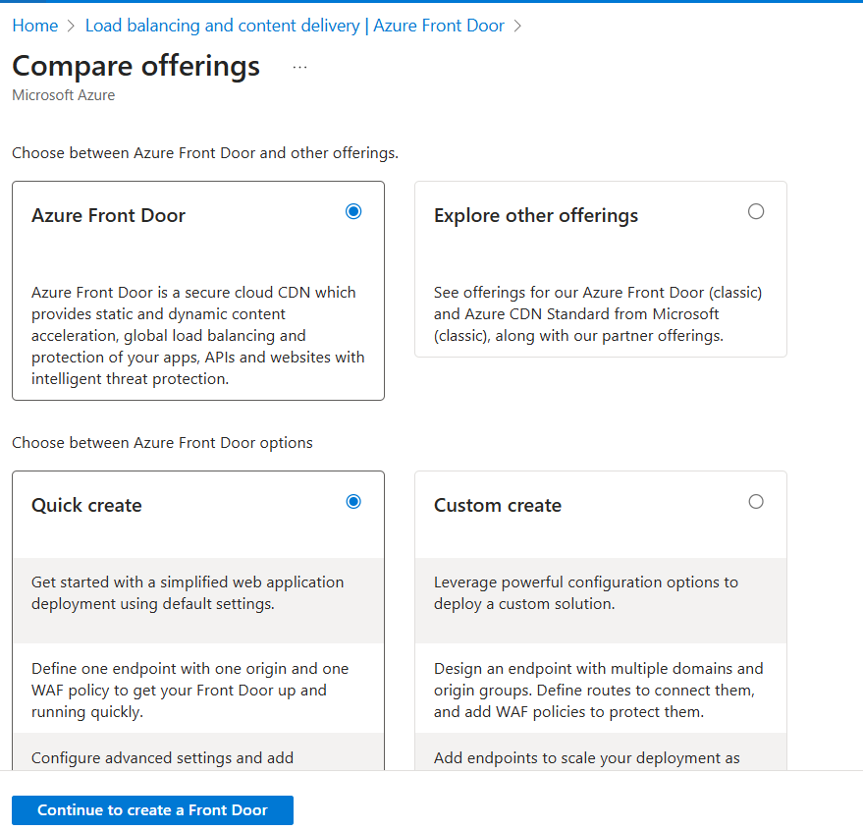

create

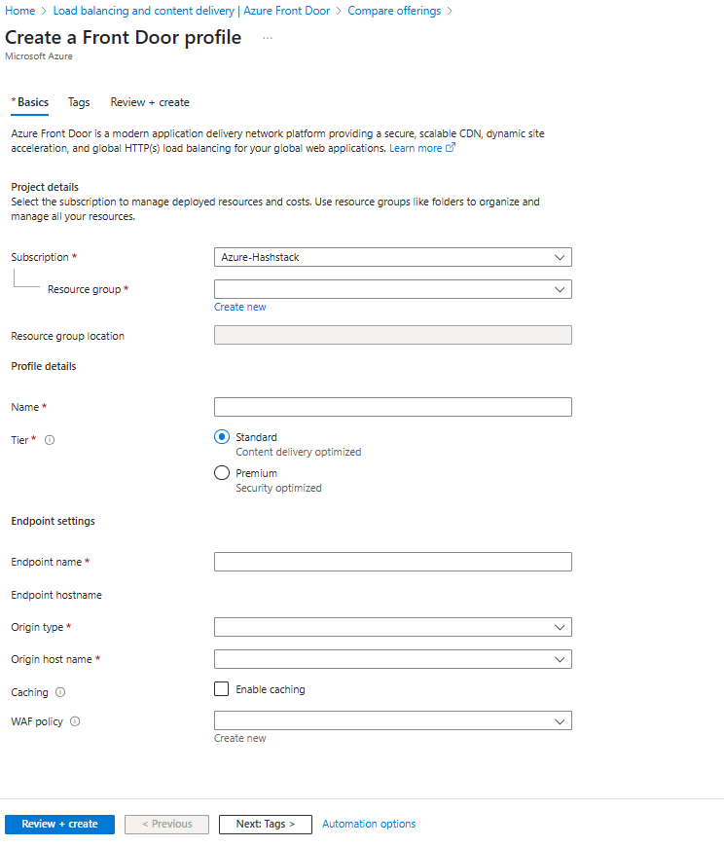

subscription

select resource group

front door name

tier [standard or premium ]

endpoint settings : endpoint name , origin type,origin hostname,if need enable caching,waf policy.

select frontdoor

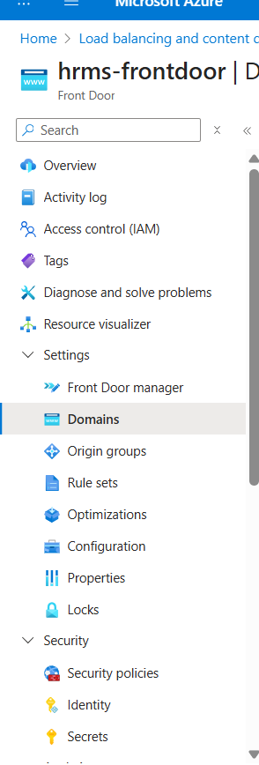

left side --- select domain

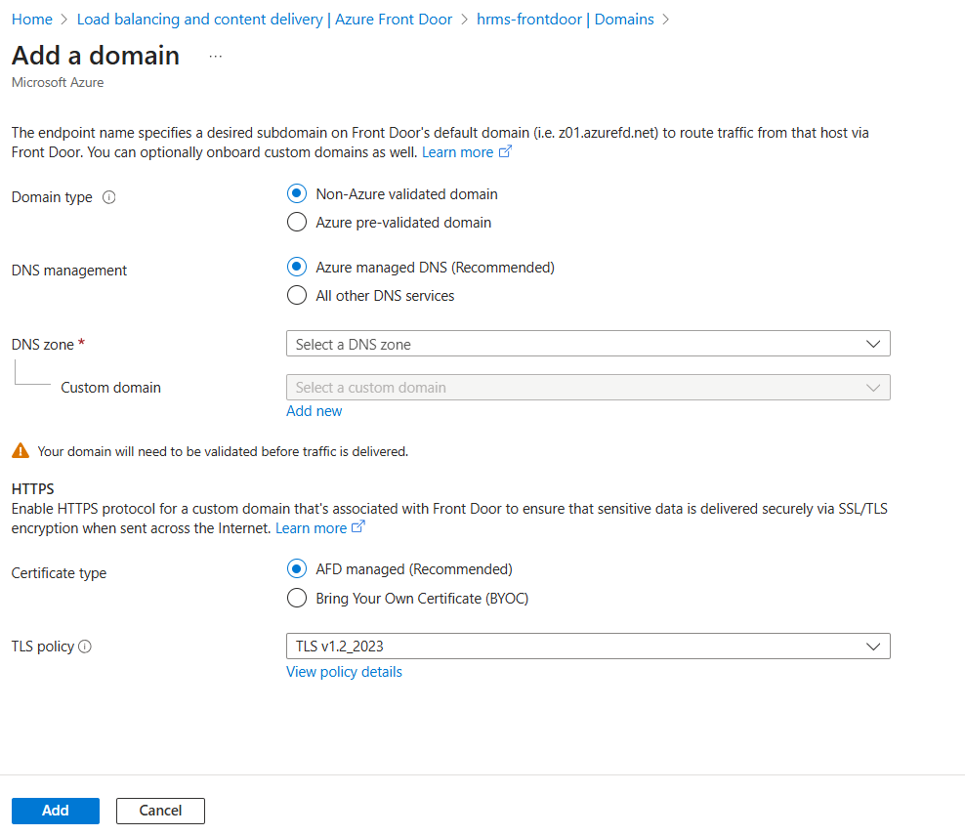

add domain

domain type [Non-Azure validated domain or Azure pre-validated domain ]

dns management [Azure managed DNS (Recommended) or All other DNS services]

dns zone

custom domain

certificate type [ AFD managed (Recommended) or Bring Your Own Certificate (BYOC)]

tls policy

go to front door manager

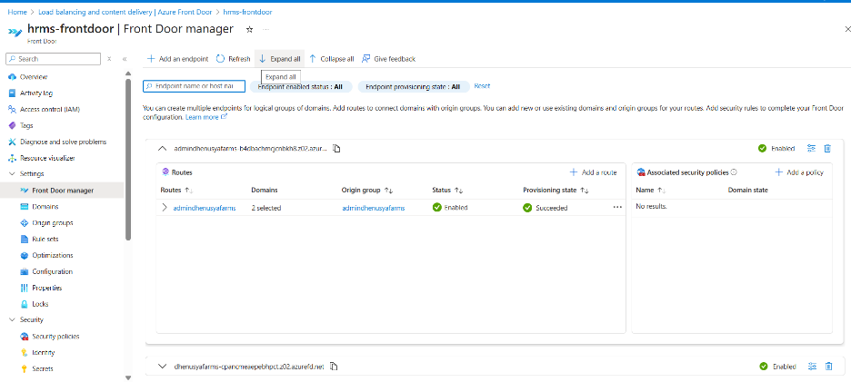

add endpoint

endpoint name then add

origin groups

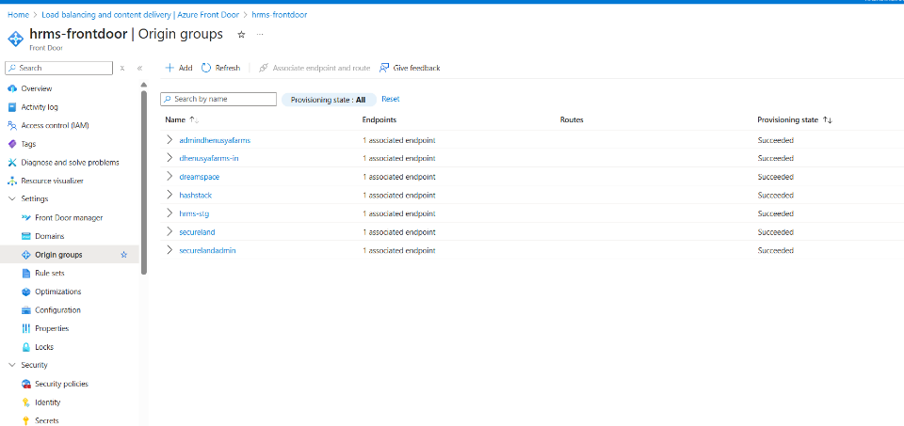

name

add an origin

name

origin type

host name

http port

https port

priority

weight

status then add

select default and add

now go to front door manager

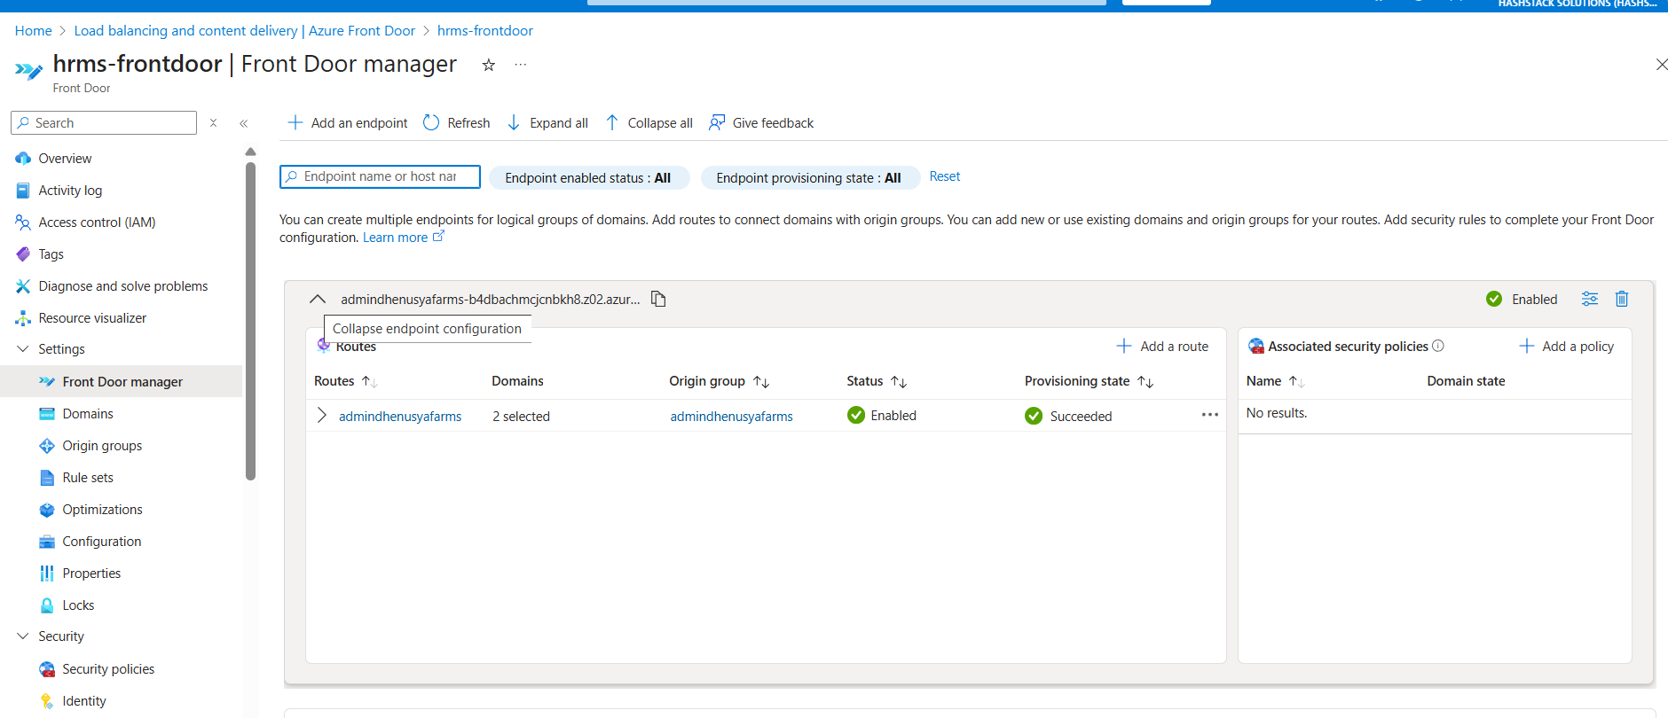

click on dropdown

here you can select endpoint

click on dropdown

add routes

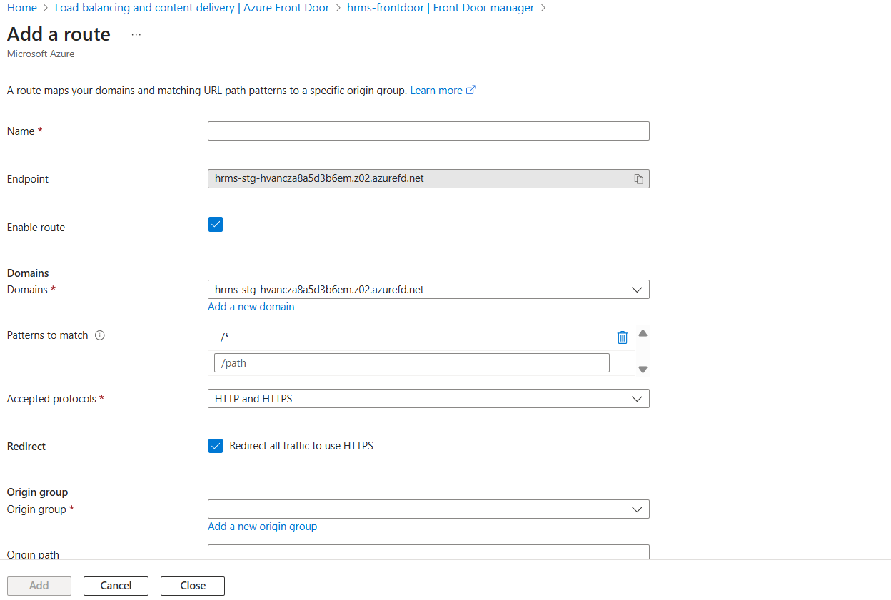

name

select endpoint

domains [select domains]

accepted protocols : http & https

origin group

forwarding protocol: https only

then add

go to domans

select domain

associate endpoint.